Gough Group

<Unposted Labour causing   
critical stop error>

<13.02.2018>

<1.0>

**Document Control**

**Version**

|  |  |  |  |
| --- | --- | --- | --- |
| **Version** | **Date** | **Author(s)** | **Description of Change(s)** |
| 1.0 | 13.02.2018 | Diane George |  |
|  |  |  |  |
|  |  |  |  |

**Related Documents**

|  |  |  |
| --- | --- | --- |
| **Document Title** | **Document Location** | **Date** |
|  |  |  |
|  |  |  |
|  |  |  |

**Document Purpose:**

This error occurs when the requestor believes everything has been posted and is trying to finish a segment.

# Most common check to resolve this critical stop error

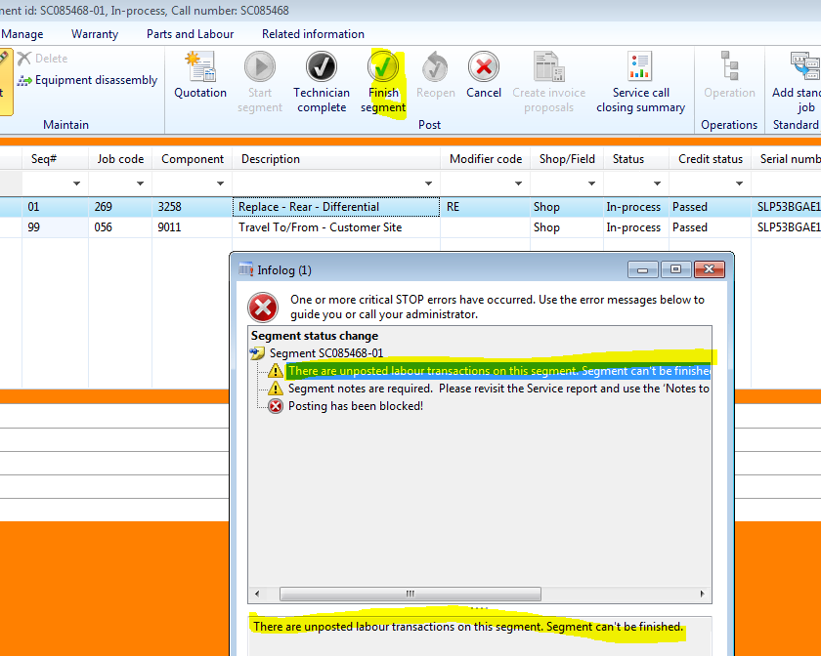

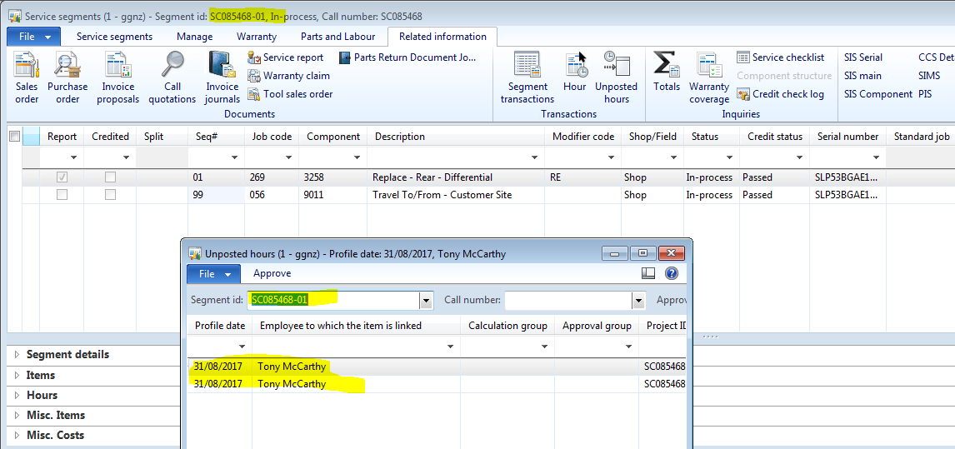

## Resolve the critical stop error caused by Unposted labour

In the **GGNZ** navigation bar, **select** *Service* from the dropdown menu

**Expand** *Service call* in Common menu box

**Select** *All service calls*

All “only open” Service Calls should be visible

**Filter** by *Service Call Num*ber that is on the job ticket

Only the related *Service Call* should be visible

**Click once** to activate the line item

**Click** *Service segment icon*

**Open** *Related info tab*

**Click** the *Unposted hours* icon in the top menu to check for unposted hours.

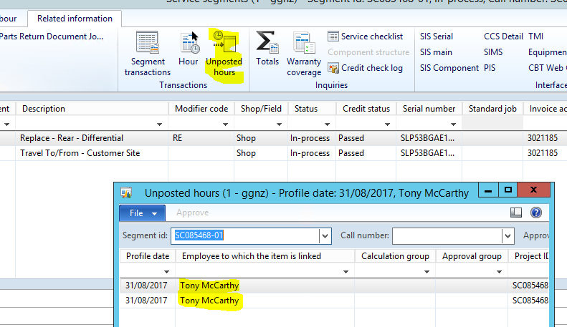

**Note down** the date of the unposted hours and the name of the employee

**Right click** the Employee’s name and **click** *view details* to open the Worker interface

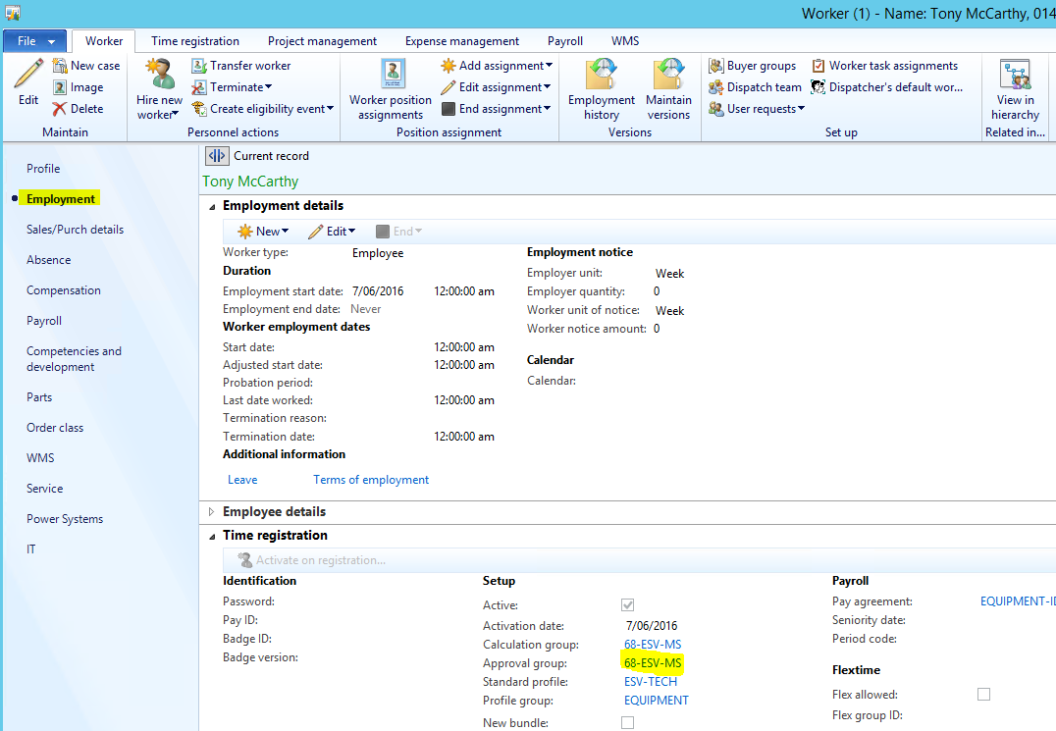

**Expand** the Employment tab

Note down the *Employee’s Approval Group code*

**Click** the *Close button*

**Return** to *GGNZ* and drop-down to Human Resources menu

**Expand** *Time and attendance menu*

**Click** on *Approve* link and a pop-up window appears

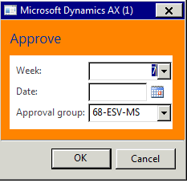

**Update** the *Date* and *Approval group* as per your noted date and approval group

**Click** the *OK button*

The pop-up window closes and reveals the full page you were on.

**Click** the *Week view button* in the top left of the screen

**Select** the *Worker* (that you noted down before) from the drop-down menu

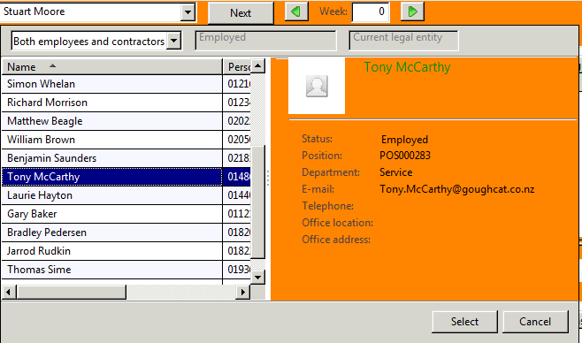

**Click** *Select button*

Check that all the boxes are ticked and the grid in the bottom section of the page is empty

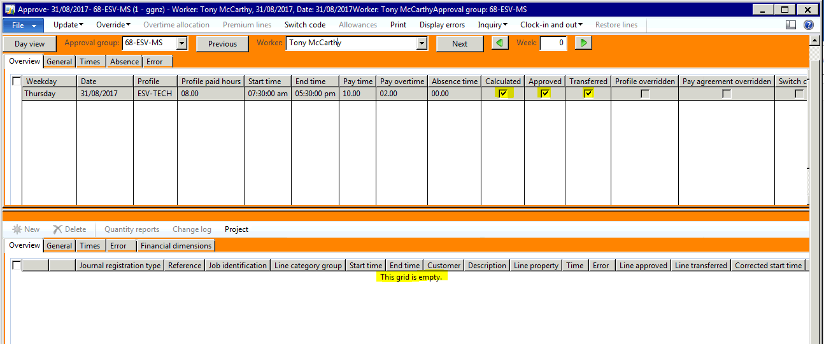

(If there are values present, please advise the requestor that there is actually labour that needs to be posted to the job)

**Return** to *GGNZ menu*

**Select** *Project management and accounting*

**Expand** *Projects menu*

**Select** *All projects*

**Filter** to the Service Call segment number (Example: SC005849-01)

**Select** the *Project service segment* that the unposted hours are on

**Click** the *Hour Journal icon*

**Look** through the line items

**Click** on the line item that has no tick under *posted column*

**Click** the *Lines icon* on the top of page

**Change** the *Project date* to today’s date

(This changes the Start Date and you need to return that to the Original Start date, you noted before)

**Manually insert** the original *Start Date*

**Add** a description: Late labour entry (and the original start date) *Example:* Late labour entry 13.02.2017

**Click** the *Close window button*

In the *Hour journal* window, select the line and **click** *Post*

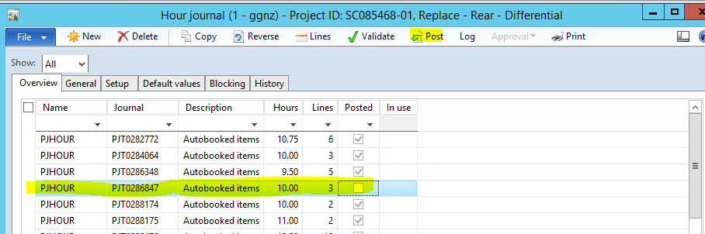

**Click** *OK button* in the next screen

The below Infolog should appear to affirm your successful completion of this Service Call.

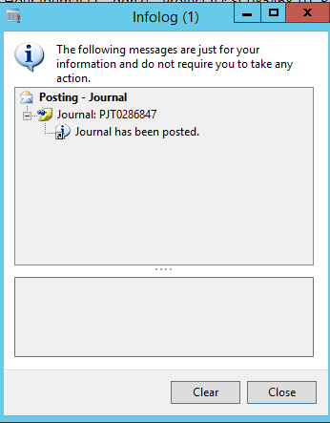

**Click** *Close button*

The requestor can now continue with their processes